**Pushing and Pulling Docker image**

Create a repository in Docker Hub.

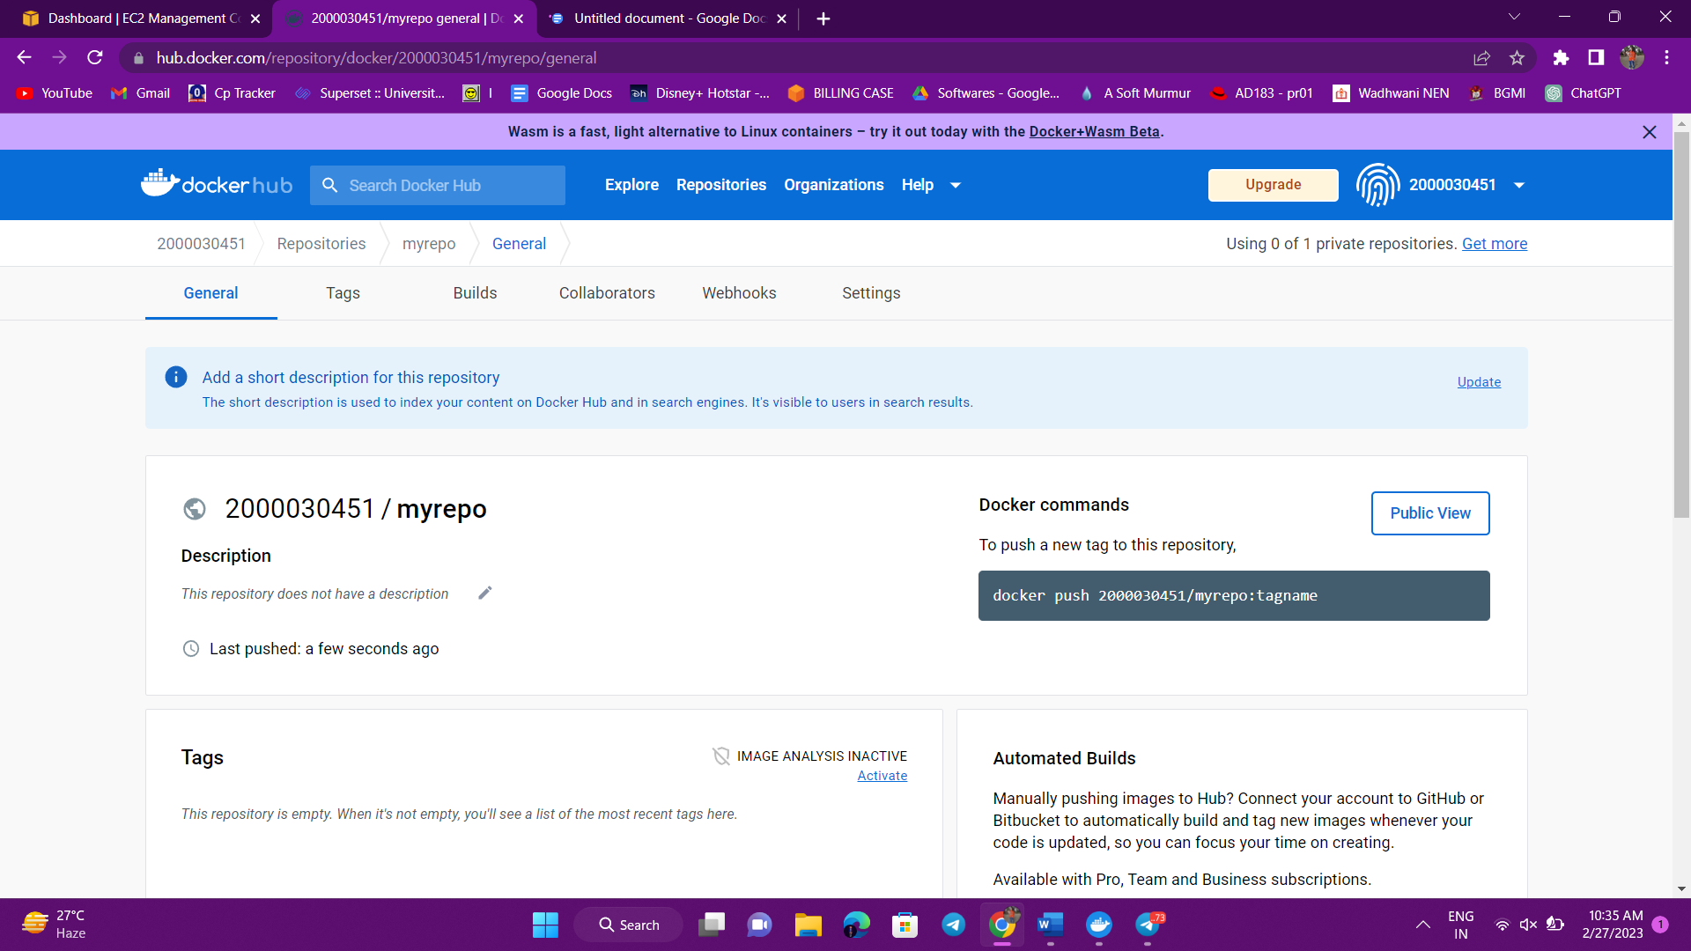

Connect your ec2 instance and update sudo and install Docker

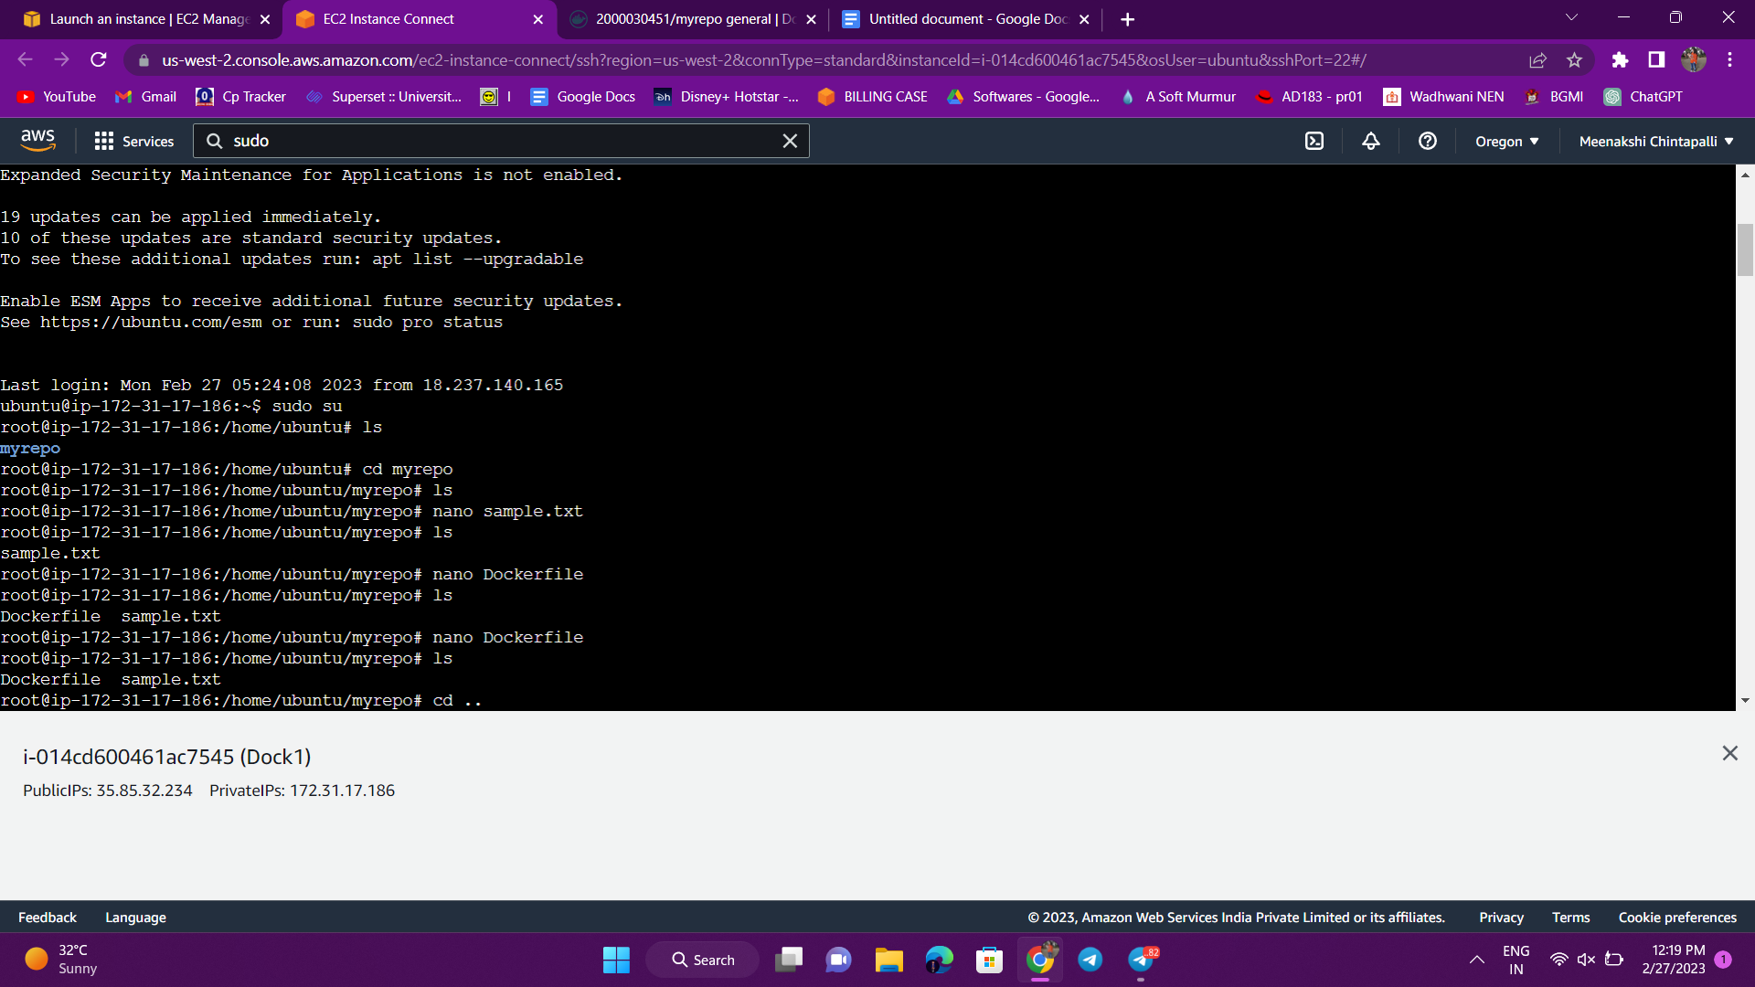

Create a directory using **mkdir myrepo**

Then create two files named Dockerfile and any sample .txt file

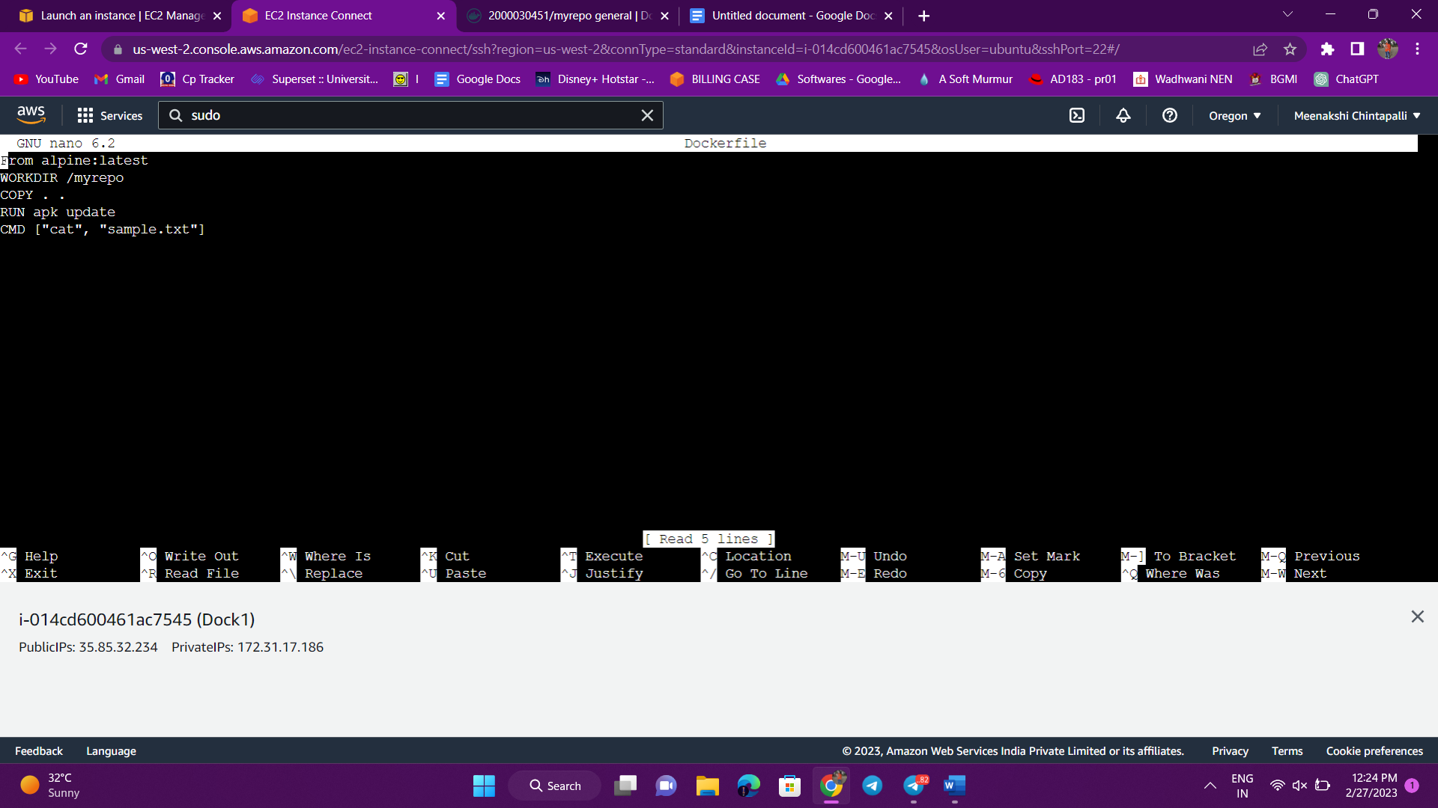

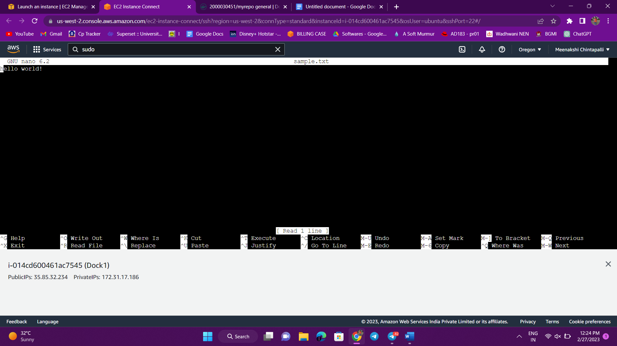 Login into your Docker Hub account using “docker login” command

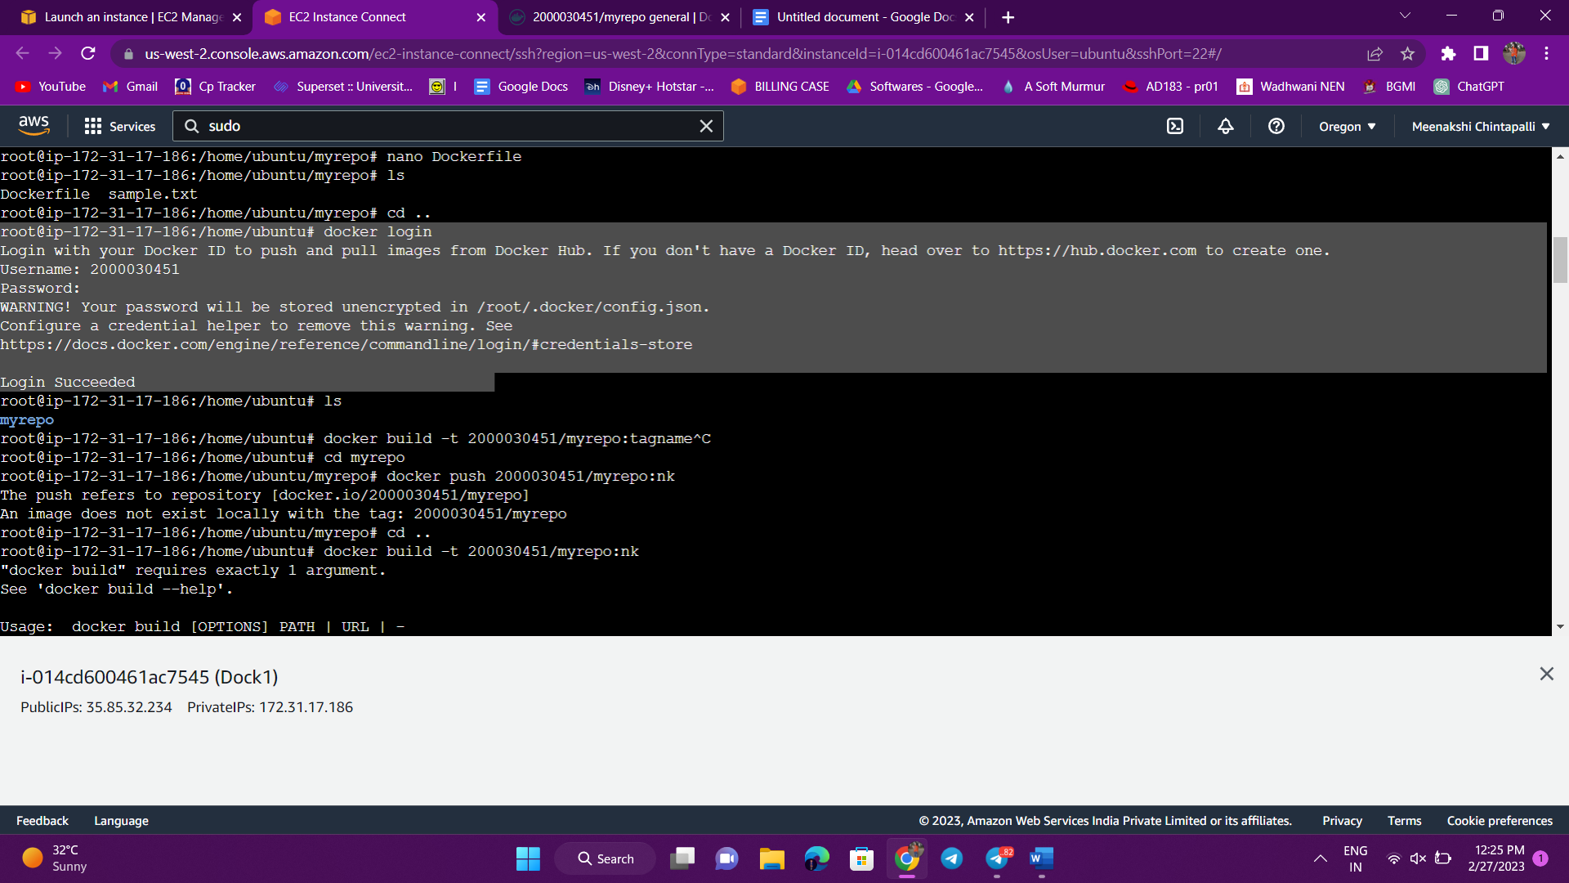 Now build the repo using the following command:

**docker build -t [username]/[reponame]:[tag name] .**

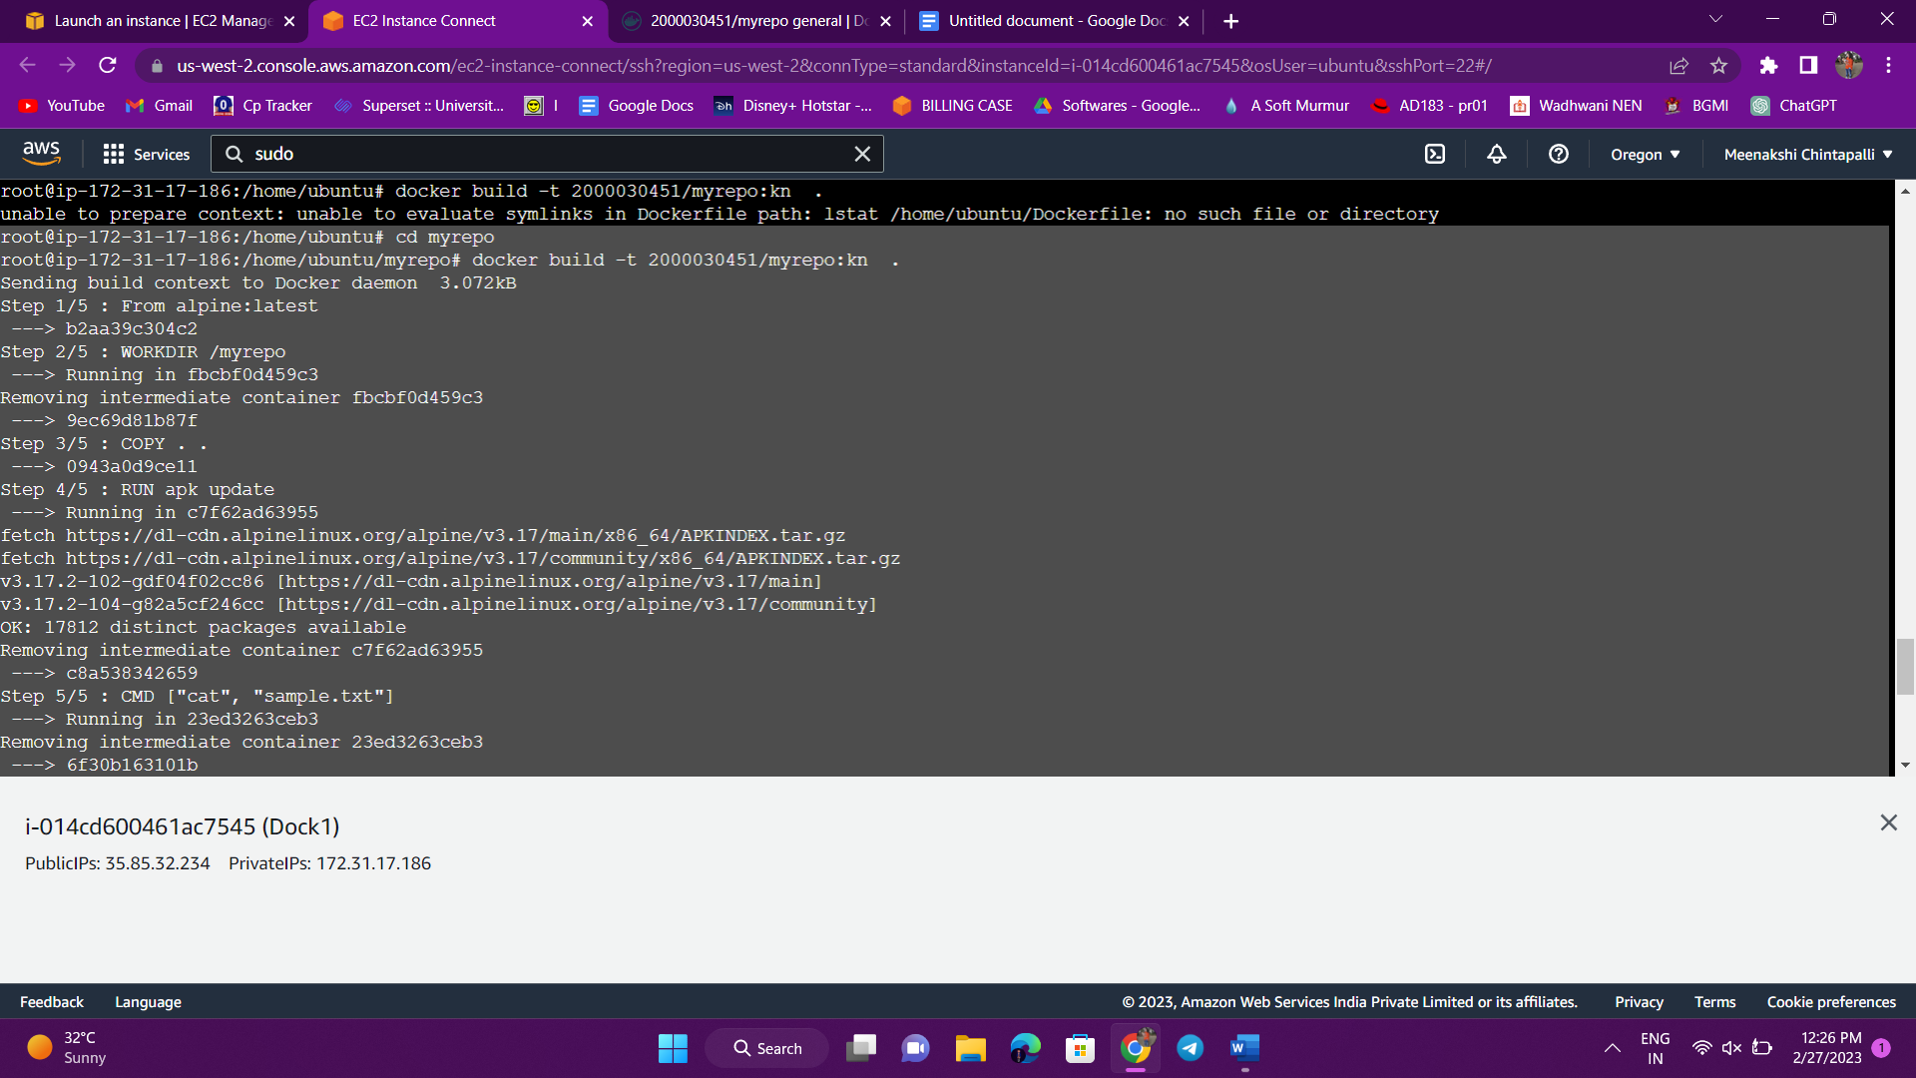

**Now check your image using “docker images ” command and**

**Now push the directory into your repository:**

**docker push [username]/[reponame]:[tag name]**

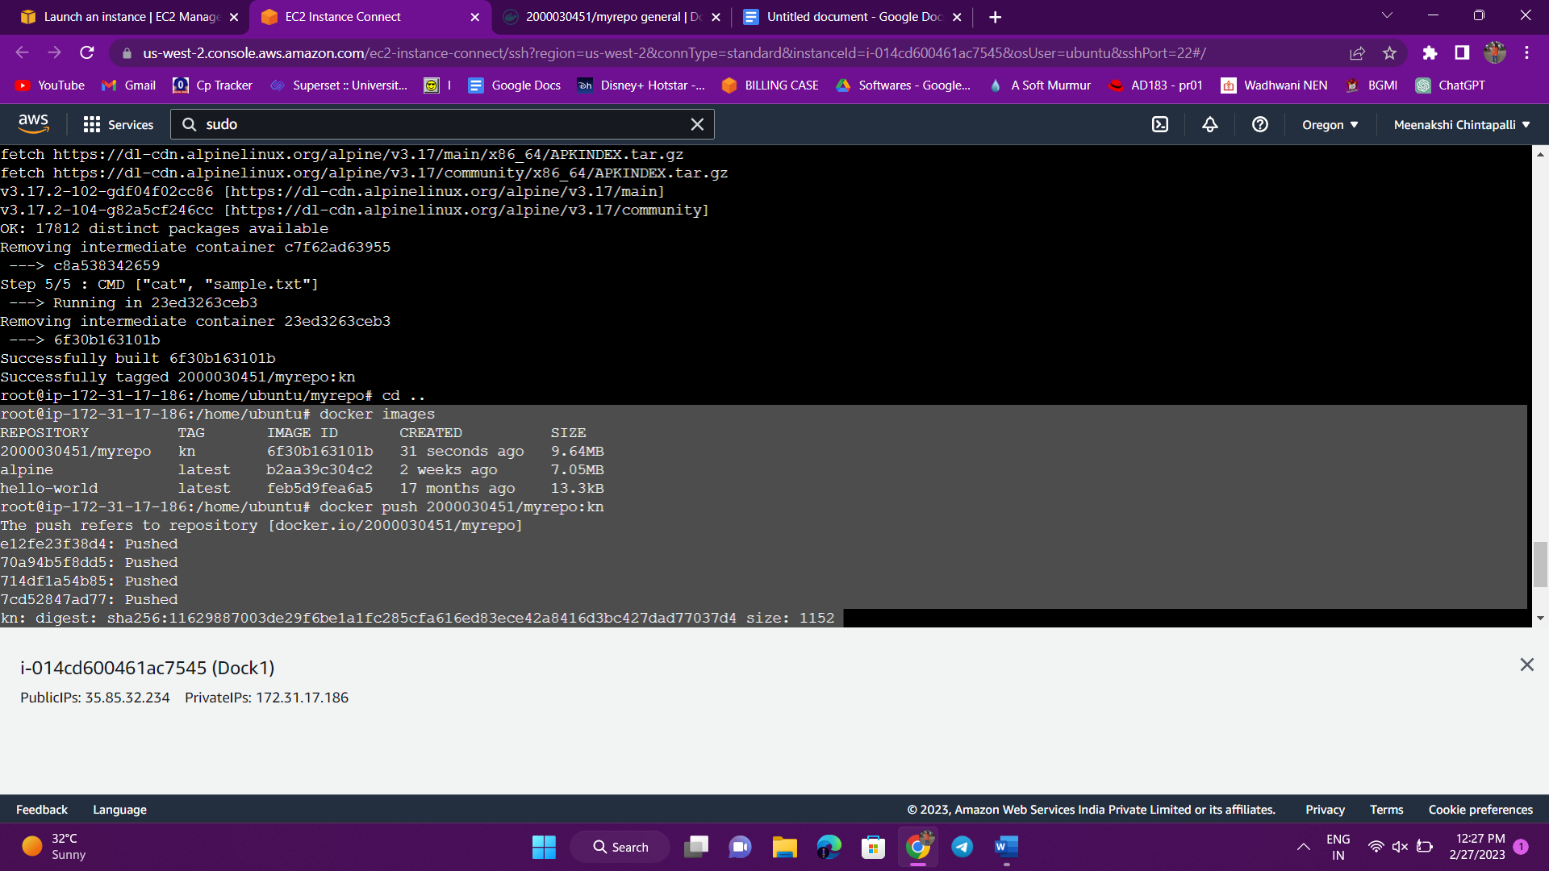

**The image will be pushed and updated in your Docker Hub repository.**

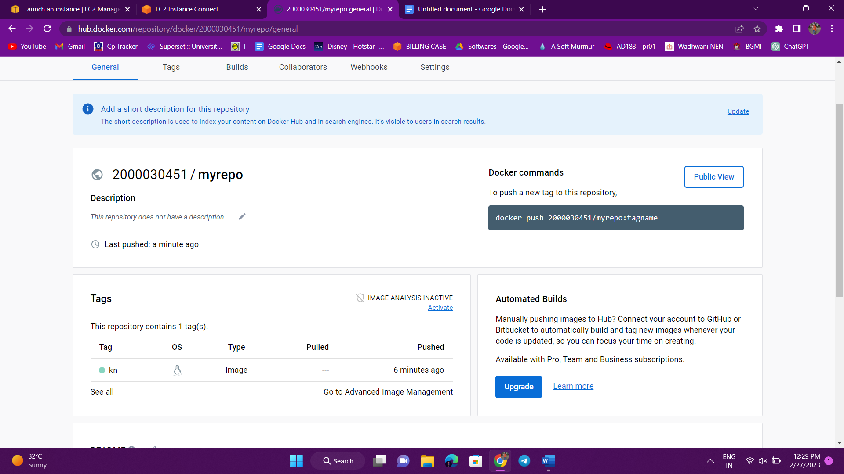

**You can also pull the repo using the command:**

**docker pull [username]/[reponame]:[tagname] and**

**Now run the file using the command:**

**docker run [username]/[reponame]:[tagname]**

